Rube Goldberg Machine
- Name: ‘The self-Operating Napkin’
- Annotated Sketch:
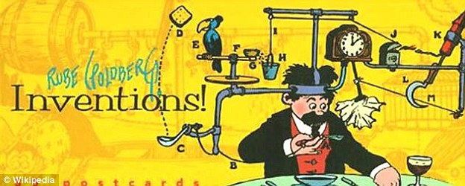
- Description of Operations:
The 'self-operating napkin' is activated when soup spoon (A) is raised to mouth, pulling string (B) and thereby jerking ladle (C), which throws cracker (D) past parrot (E). Parrot jumps after cracker and perch (F) tilts, upsetting seeds (G) into pail (H). Extra weight in pail pulls cord (I), which opens and lights automatic cigar lighter (J), setting off skyrocket (K) which causes sickle (L) to cut string (M) and allow pendulum with attached napkin to swing back and forth, thereby wiping chin.
In 1931, the Merriam-Webster dictionary defined 'Rube Goldberg' as accomplishing something simple through complex means.

- Universal Systems Model
Subsystem 1:
Output
Process
Input
Feedback

Subsystem 2:
Feedback
Input
Output
Process

- Core Technologies:
  - List and Label all the technologies included in your machine
  - Describe each of the 9 subsystem’s function
  - Label the age of technology from which your chosen item derives from (use all 9)
  - Complete a universal systems model for each of the 9 subsystems in your machine’s design
Ex. Subsystem 1: Stone Axe – Structural Technology – Paleolithic Age
String - Material technology – Neolithic Age
Automobile – Mechanical Technology – Industrial Age

Stone Axe , Energy, Human
String
Human starts the machine by swinging the stone axe towards the string
Cut String
Automobile is released

