RUBE GOLDBERG FOLLOW UP ACTIVITY
Use your rube Goldberg video as a reference to answer the following questions

- Create a scaled labeled electronic drawing of the entire machine
- Label each component of the machine based on its Core Technology
- Using the Universal Systems Model – Describe the Input, Process, Output and feedback of each of the 10 steps in the machine.
Input – Process – Output

Feedback
Example:
Shoe – Material technology
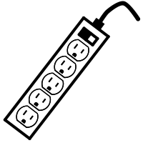

Fan– Electric

Power Supply– Electric

Input: Electricity, Power strip, Electric Fan, Human Input,
Process: Human steps on power strip button turning on the fan
Output: Spinning fan, flipped power strip switch, wind
Feedback: Fan turned on and stated on when switch was flipped.

