Student Name: ________________________

Unit : Design

Lesson 2: Design Process

File 3.2.1: Engineering Design Process

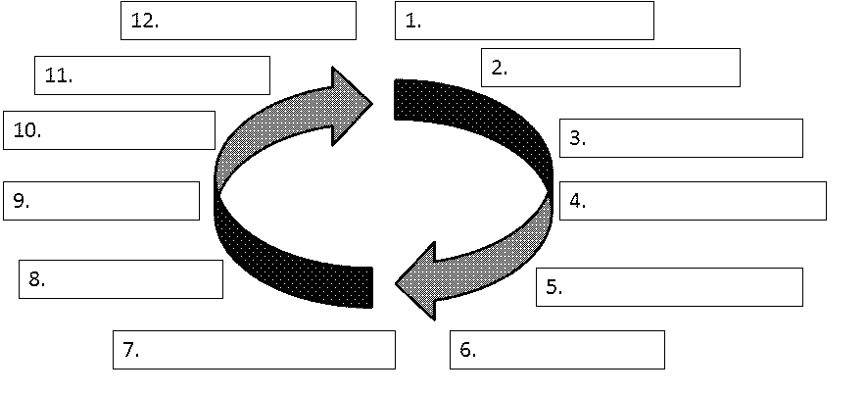
Using the PowerPoint posted to the website Titles Design Process
- For each step in the design process write one supporting statement that helps describe or explain the step
- Ex) Make a Model or Prototype - A prototype performs exactly as the final solution and is used for testing.

List The Step (In Order) followed by the supporting sentence

